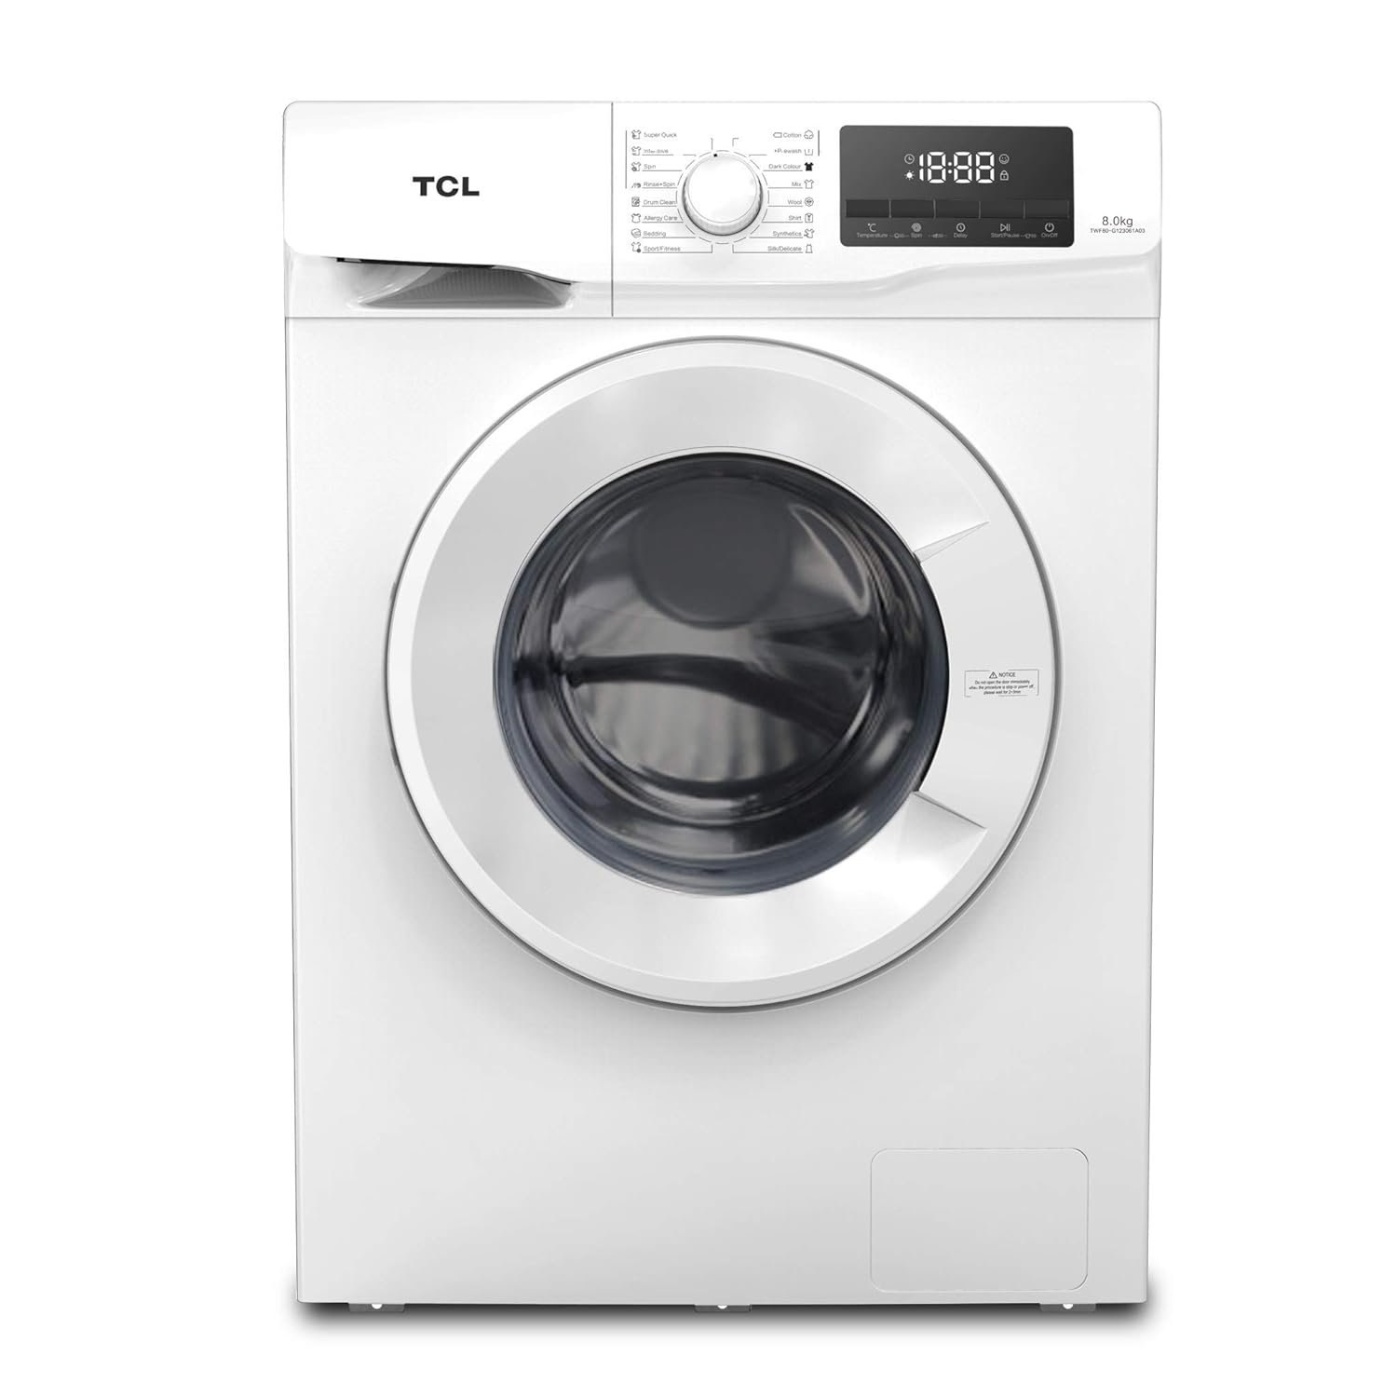

***Tcl 8k fully automatic front loading washing machine***

* **Color:**Silver
* **Available:**Out of Stock
* **Motor type:**Induction
* **Program:**10
* **Old Price:**~~Rs 23,890~~
* **New Price:**Rs 17,890